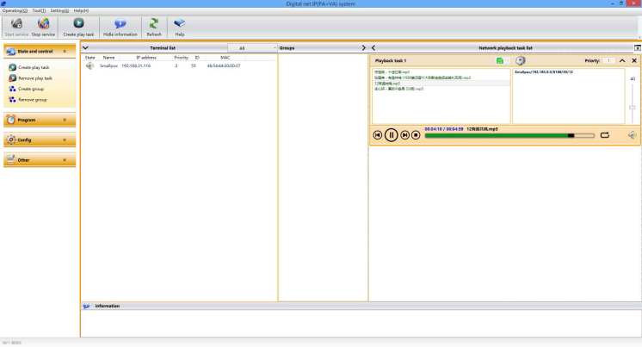
IP Network Audio System Software FIP-900SF

Feature:
✓ Server of IP network audio system and IP PA system. ✓ Support Windows 2000, Windows 7 and Win8. Win10 ✓ Support DHCP, no need to set IP address,
✓ Support line supervision, with easy UI to operate the IP system
✓ Built-in system set up, system monitor, media player, program timer, system memory functions.
✓ Cloud broadcast Mp3 file online, scheduled and matrix at pre-set time to designated loudspeaker zones. ✓ Each equipment working status could be monitored and displayed on this software.
✓ Flexible multiple level loudspeaker zone definitions, end-user can define loudspeakers into as many as possible zones at the same time.
✓ Built-inweeklytimercouldbroadcastpre-recordedvoicemessage,bell,song toselectedzonesbytriggercontact or manually operation.
✓ The head equipment to encode analog sources into digital source to be transferred over network. ✓ Support max 5 different sound cards for simultaneously sources collection.
✓ One software packet includes administrator and branch server and alarm server. ✓ Graphic maps display for visually simple monitoring and operation.

Specification:

Model | FIP-900SF
Description | IP Network Audio System Software
System | Windows 2000, XP, Win7 and Win8
Network Protocol | TCP, UDP, ARP, ICMP, IGMP
Network Speed | 10/100Mbps
Audio Sampling | 8KHz-44.1KHz, 16 bits
Transmission Rate | 8Kbps to 320Kbps
S/N Ratio | ≥90dB
Frequency Response | 20Hz-20KHz
Data Delay | 30 milliseconds
Built-in Timer | Built-in weekly timer
Converter | Built-in analog sources into digital converter
Audio Format | MP2, Mp3, PCM & ADPCM

